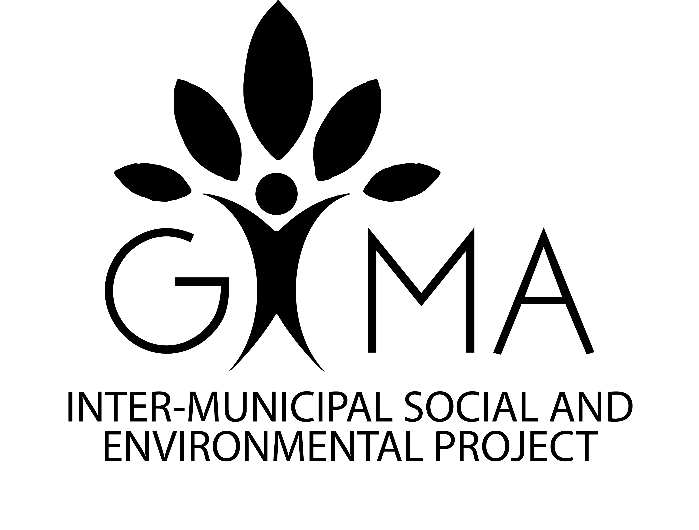
GIMA 2020 Donation Form

Bom Jesus

Sao Lucas

Labareda Regional

Name

Company

Address

Phone

Email
☐ 1 Tablet (AUD $140) Quantity: _____
Total Donation Amount (AUD $) ___________

Minas Hill will be responsible to forward the funds to the organization GIMA (APEAM – Associacao para Educacao Ambiental da Alta Mogiana) in Brazil.
To make this contribution, please use EFT as payment method:

BSB | 083 004
Account Number | 140 528 202
Account Name | Minas Hill Coffee

Thank you!
Minashill.com.au
info@minashill.com.au

